**Forever Sensor Node**

# Objective:

The objective of this project is to design a low-powered, RF-based PCB intended for installation inside coolers and ovens. Its primary function is to monitor temperature readings at 10-minute intervals and transmit this data to the food inspection department for quality control purposes. To achieve this, the design employs low-power microcontrollers, such as the EFM32 Gecko from Silicon Labs. Utilizing the low-power modes of the EFM32 at every opportunity, the goal is to optimize the board's efficiency and enable it to operate for extended periods using a coin cell battery.

## Plan of Record:

* The design incorporates a 3-volt output from a coin cell battery to power the system reliably.
* RF communication is seamlessly integrated using the nRF24L01 module, operating at a frequency of around 2.4GHz.
* A dedicated 24MHz oscillator ensures precise timing for the nRF24L01 module, guaranteeing efficient communication.
* The EFM32ZG110 microcontroller utilizes its own 24MHz oscillator for a high-frequency system clock, optimizing performance.
* For low-power operation, the microcontroller seamlessly switches to a 32KHz oscillator, conserving energy while maintaining essential functionality.
* SPI communication between microcontroller and RF module.
* Bypass capacitors are strategically placed throughout the design to mitigate surge currents in the power rail, ensuring stable power distribution.
* The I2C communication protocol is seamlessly integrated, facilitating seamless data exchange between the EFM32 microcontroller and the humidity sensor.
* A jump-start circuit has been implemented to ensure rapid and reliable startup of the oscillators, enhancing overall system stability.
* The antenna system is meticulously designed to provide a reliable communication range of approximately 50 meters, meeting the project requirements effectively.
* The design also incorporates essential features such as a bootloader, flash memory, and emergency power input pins, enhancing the device's versatility and reliability in various operational scenarios.
* Board size of about 2.2inch x 2.5inch.

## Compromises:

* Test points are not added due to size constraint.
* LED indicators are not added due to high power consumption.

## Risk Reduction:

* Implemented headers to facilitate power verification, enhancing safety and ease of testing.
* Strategically placed components apart from each other to minimize confusion during soldering, ensuring efficient assembly and reducing the risk of errors.

## What it means for the system to work:

* Reliable generation of 3 volts from the coin cell battery ensures consistent power supply to all components.
* The oscillators reliably generate the expected clock frequencies, ensuring accurate timing for the system's operation.
* SPI communication between the microcontroller and the RF module is established and functioning properly, enabling seamless data exchange.
* I2C communication between the microcontroller and the humidity sensor is successfully established, allowing for accurate humidity measurements.
* The microcontroller demonstrates the ability to efficiently switch between low-power mode and normal mode, optimizing energy consumption.
* The system achieves reliable signal transmission up to 50 meters, meeting the project's communication range requirements effectively.

# A black background with white lines and symbols Description automatically generated with medium confidenceSchematic:

# A blue screen with a circuit board Description automatically generatedA computer screen shot of a computer Description automatically generatedLayout:

The schematic illustrates a module-wise arrangement of the board. Power conditioning occupies the top left corner, with the sub-layout of the nRF module directly below it. Beneath the sub-layout lies the oscillator circuit necessary for the nRF module's operation. Positioned in the top right corner is the humidity sensor, accompanied by the requisite pull-up resistor for I2C communication. Finally, the microcontroller and its associated high-frequency and low-frequency oscillators are situated.

This arrangement of components in the prototype layout serves the purpose of enhancing identification and debugging processes.

# Board:

# Hardware Design:

## EFM32ZG110 (QFN24):

The EFM32ZG110 (QFN24) from Silicon Labs is an ultra-low-power microcontroller widely utilized in various low-power applications. Here are some key features specific to the EFM32ZG series:

* It boasts an exceptionally low power consumption, operating at just 0.5 μA in Stop mode and consuming 114 μA/MHz in Run mode, making it ideal for battery-powered devices where energy efficiency is crucial.
* Powered by an ARM Cortex-M0+ processor clocked at 24MHz, the EFM32ZG110 delivers reliable and efficient performance for a range of embedded applications.
* With a fast wake-up time of only 2 µs, the microcontroller swiftly transitions from low-power modes to active operation, minimizing power consumption during idle periods.
* The EFM32ZG110 offers ample memory resources, including up to 32 kB of Flash memory for program storage and 4 kB of RAM for data storage, ensuring sufficient space for code and data storage in resource-constrained applications.

These features make the EFM32ZG110 microcontroller an excellent choice for developers seeking to design energy-efficient, high-performance embedded systems. Additionally, the availability of template schematics further simplifies the development process, enabling rapid prototyping and deployment of low-power applications.

## nRF24L01:

The NRF24L01 from Nordic Semiconductors is a versatile RF transceiver module commonly used for wireless communication in various applications. Here are some key features of the NRF24L01 module:

* 2.4GHz ISM Band Operation: The NRF24L01 operates in the globally available 2.4GHz ISM (Industrial, Scientific, and Medical) band, allowing for interference-free communication in this frequency range.
* Ultra-Low Power Consumption: The module features exceptionally low power consumption, drawing only 900nA in power-down mode and 26uA in standby mode. This enables energy-efficient operation and prolongs battery life in battery-powered devices.
* On-Chip Voltage Regulator: With an integrated voltage regulator, the NRF24L01 simplifies power management by providing a regulated supply voltage for the module's operation, ensuring stable performance across varying input voltages.
* Compatibility: The NRF24L01 is backward compatible with previous generations of NRF24 series modules, including the nRF2401A, nRF2402, nRF24E1, and nRF24E2. This compatibility allows for easy migration and interchangeability with existing designs, enhancing flexibility and versatility.

These features make the NRF24L01 an excellent choice for applications requiring reliable and efficient wireless communication in the 2.4GHz frequency band, such as IoT devices, remote control systems, and sensor networks.

## HDC1080:

The HDC1080 from Texas instrument is a high-performance humidity and temperature sensor with several notable features:

* Relative Humidity Accuracy: The HDC1080 offers a typical relative humidity accuracy of ±2%, ensuring precise measurement of humidity levels in various environmental conditions.
* Temperature Accuracy: With a typical temperature accuracy of ±0.2°C, the HDC1080 provides highly accurate temperature measurements, enabling reliable monitoring of temperature changes.
* Measurement Resolution: The sensor boasts a 14-bit measurement resolution, allowing for detailed and precise measurement of both humidity and temperature parameters.
* Ultra-Low Power Consumption: In sleep mode, the HDC1080 consumes just 100nA of current, making it highly energy-efficient and suitable for battery-powered applications where power consumption is critical.
* I2C Interface: The HDC1080 features an I2C (Inter-Integrated Circuit) interface for communication with microcontrollers or other devices, facilitating easy integration into a wide range of systems and platforms.

These features make the HDC1080 an excellent choice for applications requiring accurate and reliable measurement of humidity and temperature.

# Schematic and Layout design:

Here flux.ai is used to design schematic diagram and layout, which is a web-based PCB design tool, where users can design up to 5 projects for free by using the vast library.

## nRF24L01 Sub-layout:

While flux.ai provides nRF24L01-based breakout boards as symbols and footprints in their library, I opted to design a custom sub-layout for the following reasons:

* **Enhanced Signal Integrity**: Custom sub-layouts offer improved signal integrity properties, reducing noise by incorporating:
  + 1. A continuous ground planes.
    2. Decoupling capacitors.
    3. Separate return paths for each component.
* **Antenna Shape**: Tailoring the antenna shape to fit our specific requirements ensures optimal performance and signal reception.
* **Custom PCB Design**: Integrating a breakout board into our custom PCB layout can result in an awkward appearance. Therefore, I chose to create a sub-layout that includes the nRF24L01 module and other necessary components, along with a custom antenna design.

By creating this sub-layout, I not only address our project's unique needs but also contribute to the flux.ai library. Other users can benefit from our design and incorporate it into their projects, fostering collaboration and innovation within the community.

After careful reference to the schematic outlined in the datasheet, I have developed the following schematic and sub-layout.

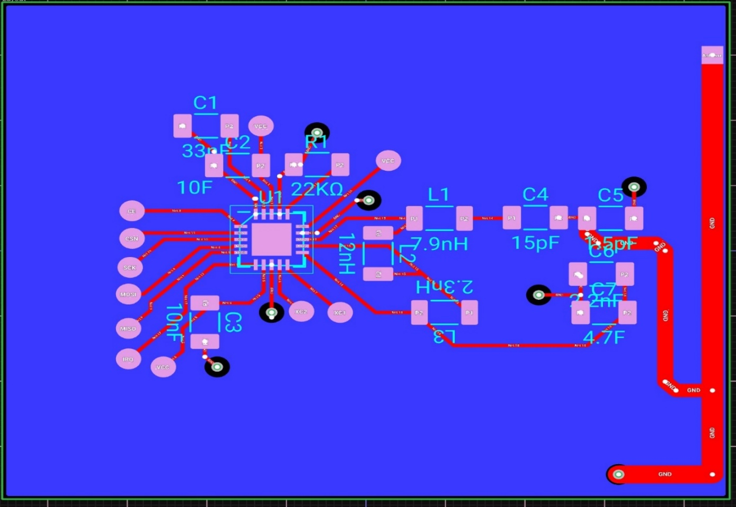

The implementation of this sub-layout method offers several benefits:

1. Modularization: It helps modularize the schematics and layout, keeping schematics with multiple components clean and organized.
2. Time-saving Import: Unlike other PCB design tools, I can import the layout directly, saving a significant amount of time during the design process.
3. Plug and Play: It follows the plug-and-play principle, allowing for seamless integration and interchangeability of sub-layouts within different projects.
4. 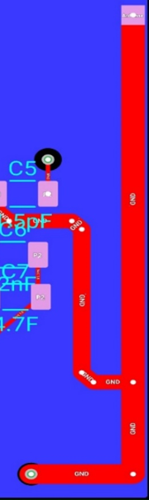Collaborative Editing: Other users can easily edit the sub-layout by forking or cloning it, fostering collaboration, and enabling iterative improvements.

## F Antenna design:

The antenna design in our layout differs from the structure depicted in the breakout board image shown on the left.

By leveraging the copilot embedded in the tool, learned about antenna functionality, and explored various types suitable for low-power design. Following a quick internet search, decided to implement a custom antenna shape.

I found the antenna trace width to be 54 mil, with a head length of approximately 750 mil and a tail length of 500 mil, including the L shape. At the end of the head, reshaped the pad to a rectangular shape to match trace to achieve a 50Ω impedance match.

## **A circuit board with many small square holes Description automatically generated with medium confidence EFM32ZG110F4-QFN24:**

## For my project, I have chosen to utilize the EFM32ZG110F4 series microcontroller in a QFN package with 24 pins. Unfortunately, this specific variant was not available in the library.

Addressed this issue by forking and modifying the existing component symbol and footprint of the EFM32HG308F32G-C-QFN24 microcontroller which matches the dimension 5mmx5mm and 24 pins.

The footprint on the right is derived from the EFM32HG308F32G-C-QFN24(left), with modifications made to pins DECOUPLE, VDD_DREG, PD7, and PD_6 to align with the specifications outlined in the datasheet. This modified module has been published to the general library to encourage collaboration.

## UART Bootloader:

Usually EFM32 series microcontrollers bootloaded after manufacturing, but if I want to tweak any memory and interrupt sequence, I may need to bootload at the time. So provided separate header pins for that.

## Challenges encountered:

1. **ASE-24MHz Oscillator Import:** Attempted to import the symbol and footprint for the 24MHz ASE oscillator from snapEDA, tailored for KiCAD and Eagle software. While successful in obtaining the symbol, encountering difficulty acquiring the footprint. As a workaround, utilized the existing ASE oscillator footprint available in the flux library.
2. **Simulation:** Efforts to simulate the antenna section of the nRF24L01 module were hindered by the absence of simulation models for several components, including the nRF24L01 module itself. Consequently, I was unable to verify the basic functionality of the newly designed antenna shape.
3. **Repour:** Not able to discover how to avoid pouring copper in the bottom layer under the antenna.
4. **Freeze:** Due to lack of internet bandwidth, observed some lag in placing and routing components.
5. **Polarity:** Polarity of the component considered for resistor and ceramic capacitor, which requires unnecessary rotation of while placing and routing the components.
6. **Text Field:** Text adding option is missing from schematic panel, which hinders users from defining about the circuit functionality like power conditioning, timers, micro, Reset circuit etc.

## Merits of the tool:

* Sub-layout
* Copilot
* General library collaboration
* Vast resource
* Plug and play kind approach.
* Cloning and forking projects.
* Simulation

## Areas of improvement:

* Enhancing routing practices to minimize the use of traces on the bottom layer, optimizing signal integrity and reducing potential interference.
* Despite the presence of internal voltage regulators in microcontrollers and RF modules, considering the use of external voltage regulators to supply power for other components. This can enhance stability and reliability, especially in demanding or high-current applications.

# Future scope:

Implement LDO, test points and ESD protection to reduce the board failure risk due to environmental stress, differential pair for I2C and SPI traces and also minimize the dimension 1inch x 1inch.

# Key learnings:

* Understanding the criteria for selecting low-power microcontrollers suitable for specific applications, considering factors such as power consumption, processing capabilities, and peripheral features.
* Gaining proficiency in schematic and layout design using the flux.ai tool, including component selection, signal routing, and design optimization.
* Acquiring fundamental knowledge about RF antenna design principles, including trace width, length, and impedance matching techniques.
* Familiarization with the selection process for temperature and humidity sensors, considering factors such as accuracy, resolution, and interface compatibility.
* Design Tradeoffs: Understanding the tradeoffs involved in PCB design, including cost, time, and quality considerations. Balancing these factors to achieve project objectives effectively.

# Project Link:

1. <https://www.flux.ai/jithendrahs/efm32zg110f4-qfn24>
2. <https://www.flux.ai/jithendrahs/nrf24l01sublayout>
3. <https://www.flux.ai/jithendrahs/forever-sensor>

# References:

1. <https://www.silabs.com/mcu/32-bit-microcontrollers/efm32-zero-gecko/device.efm32zg110f4-qfn24?tab=specs>
2. <https://www.silabs.com/documents/public/data-sheets/efm32g-datasheet.pdf>
3. <https://www.silabs.com/documents/public/user-guides/ug421-efm32zg-stk3200a-user-guide.pdf>
4. <https://www.silabs.com/documents/public/user-guides/ug421-efm32zg-stk3200a-user-guide.pdf>
5. <https://forum.digikey.com/uploads/short-url/e80y2eyas06YrfRX9rJzodnKfEZ.pdf>
6. <https://hackaday.io/project/28606/gallery#536056ed3ae9904b4cf4518ee4207eda>
7. <https://community.silabs.com/s/article/using-an-efm32-starter-kit-as-an-external-debugger-1?language=en_US>
8. <https://github.com/lemcu/EFM32ZG110-quick-start-board>
9. <https://colinkarpfinger.com/blog/2010/the-dropouts-guide-to-antenna-design/>
10. <https://forum.digikey.com/t/getting-started-with-efm32-zero-gecko-arm-cortex-m0/13435>
11. <https://www.ti.com/general/docs/suppproductinfo.tsp?distId=10&gotoUrl=https%3A%2F%2Fwww.ti.com%2Flit%2Fgpn%2Fhdc1080>
12. <https://www.sparkfun.com/datasheets/Components/SMD/nRF24L01Pluss_Preliminary_Product_Specification_v1_0.pdf>
13. <https://abracon.com/Oscillators/ASEseries.pdf>
14. [Flux – The Future of Electronics Design (youtube.com)](https://www.youtube.com/@buildwithflux)